FitBuddy-AI — AI-Powered Personalized Workout & Nutrition Planner
Project Design Phase-II
Technology Stack (Architecture & Stack)
Date | 22/09/2026
Team ID | SWTID-2026-9413
Team Size | 4
Project Name | FitBuddy-AI
Team Leader: Praveenkumar J | Team Members: Praveen, PremAnand R, Susibala A

Technical Architecture
The system follows a layered architecture. A browser talks to FastAPI through Jinja2-rendered pages, while external clients can use the same backend through a parallel JSON REST API. Incoming data is validated by Pydantic schemas, business logic lives in the routes and CRUD layers, and a dedicated AI service module (app/ai.py) wraps the Google Gemini client — with a demo-mode fallback so the app runs without any external API dependency. All persistent data is stored in SQLite via SQLAlchemy.
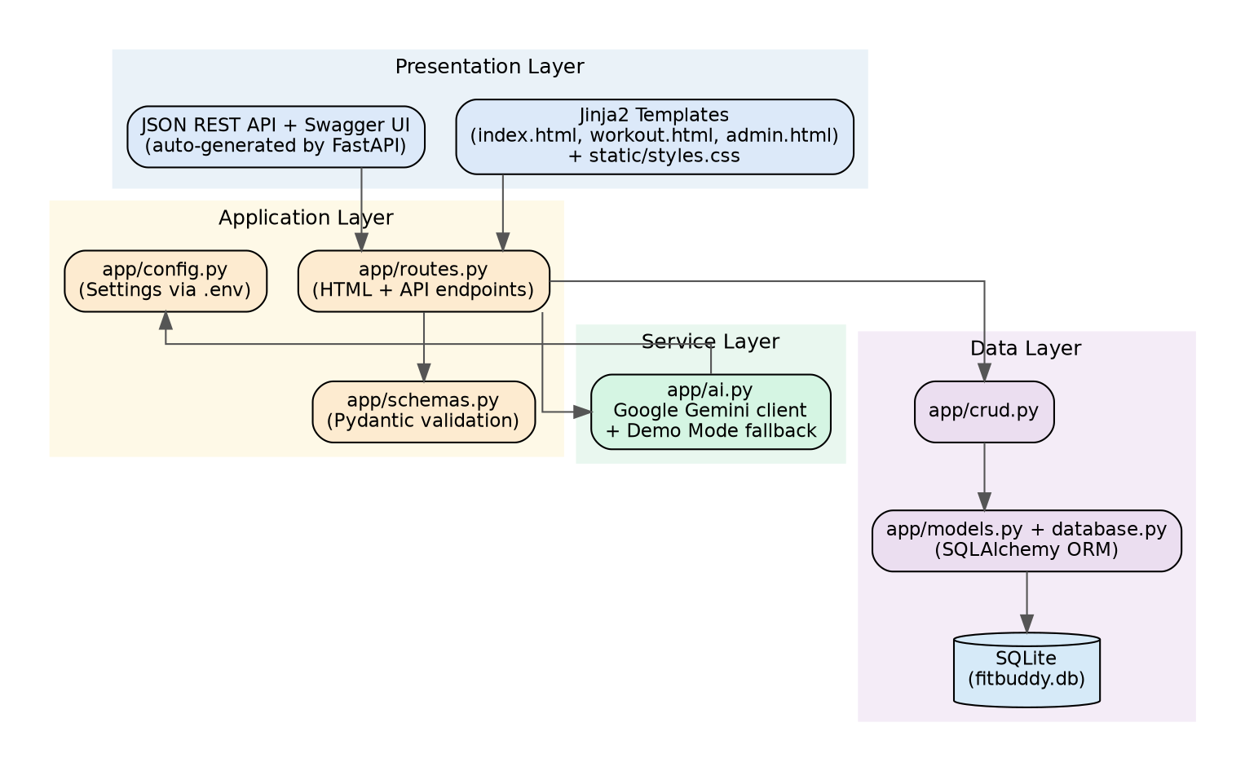

Table-1: Components & Technologies
S.No | Component | Description | Technology
1 | Web Framework & Server | Routes HTTP requests, serves both HTML pages and JSON, runs the ASGI app | Python, FastAPI, Uvicorn
2 | Request Validation | Validates and normalizes profile, feedback, and settings data | Pydantic v2, pydantic-settings
3 | Data Persistence | Stores users and generated plans | SQLAlchemy ORM, SQLite (fitbuddy.db)
4 | AI Service Layer | Builds prompts and calls Gemini for workout plans, nutrition tips, and feedback-based updates; falls back to demo content when no key is set | google-genai client, Gemini models (gemini-3.1-pro-preview / gemini-3.8-flash)
5 | Presentation Layer | Renders the profile form, plan page, and admin dashboard | Jinja2 templates, HTML/CSS
6 | Testing | Automated smoke tests against the FastAPI app | Pytest, FastAPI TestClient

Table-2: Application Characteristics
S.No | Characteristics | Description | Technology
1 | Open-Source | Entirely built on the open-source Python/FastAPI ecosystem | Python, FastAPI, SQLAlchemy
2 | Configurable | Behaviour (demo mode, admin access, database location, models used) is driven by environment variables | .env / pydantic-settings
3 | Self-contained | Runs locally with a file-based SQLite database and no mandatory external services | SQLite
4 | Documented API | Automatically generated, interactive API documentation | FastAPI Swagger / OpenAPI
5 | Testable | Core flows are covered by an automated test suite | Pytest

